T4.2 – Analyze a Strategic Move in the Software Industry
Student name: Hyechan Shin
Student number: 003991873

Case and Company Name

1. The strategic move

Miradore is a Finnish SaaS company was founded in 2006 in Lappeenranta and provides solutions in mobile device management and Enterprise Device Management (MDM, EMM) for mobile devices, and was acquired by GoTo in 2022. This acquisition brought Miradore’s remote work and security management, offering greater value to all stakeholders through enhanced IT support and device management solutions in GoTo. (Wikipedia) The combination of GoTo and Miradore stands out by expanding its capabilities to offer customers a differentiated advanced solution.
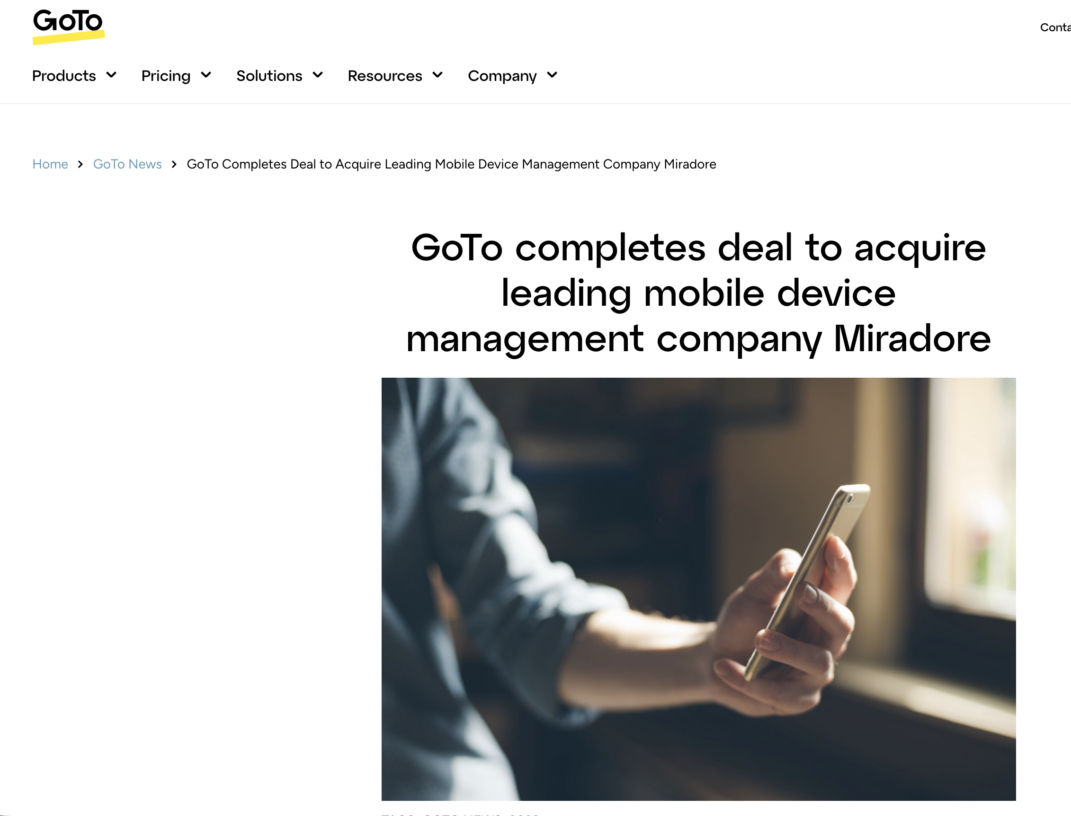
Source: https://www.goto.com/blog/goto-acquires-miradore

2. Value creation
This acquisition clearly provided value for both companies. Miradore customers have capability to expand their IT capability needs into GoTo’s wider range of IT solutions, while GoTo can offer MDM capabilities to its existing customers.

3. Strategic motivation
Miradore was a strategic puzzle piece that filled the MDM (Mobile device management) gap in GoTo's existing IT-management portfolio. For instance, GoTo was missing the capability of assisting customers with MDM/ EMM solutions. There are several benefits GoTo received after the acquisition, such as expansion of the customer base and market and MDM expertise and technologies. Existing Miradore customer were also introduced into GoTo’s ecosystem, expanding the existing GoTo customer base. The acquisition can be seen as a horizontal acquisition, as both GoTo and Miradore operates in IT software.

4. Your assessment
I do see the acquisition as positive, as GoTo now well-equipped with MDM/ EMM solutions and stands out in the market with existing IT products they provides, also integration with GoTo’s different products, internal tools and knowledge share and sharing the set of customer brings numerous benefit to GoTo.

However, it also comes with a technical integration challenges. For instance, GoTo is already equipped with existing IT products, while Miradore has its own platform. The integration requires significant development resources and align with existing systems and company culture. One risk I see is the integration might take longer than it seems, which could delay the benefit of acquisition.

5. Evidence and sources
According to Buxmann, Diefenbach and Hess (2013), acquisition can provide numerous benefits and can be an excellent strategy for software companies. In the case of GoTo and Miradore, the acquisition provided GoTo with MDM capabilities and expertise, which strengthened its existing IT management portfolio. Therefore, the acquisition can be seen as a win-win situation, as GoTo gained new capabilities while Miradore gained access to GoTo’s wider ecosystem and customer base.

Simo Salmensuu. (2022, July 19). Miradore acquired by GoTo – what happens next? | Miradore. Miradore. https://www.miradore.com/blog/miradore-acquired-by-goto-what-happens-next/

GoTo completes deal to acquire leading mobile device management company Miradore. (2022, September 28). GoTo. https://www.goto.com/blog/goto-acquires-miradore

AI Declations
ChatGPT was used to grammar check.

